# [MS-E2112 - Multivariate statistical analysis](https://mycourses.aalto.fi/course/view.php?id=7621) – Home exercise 3

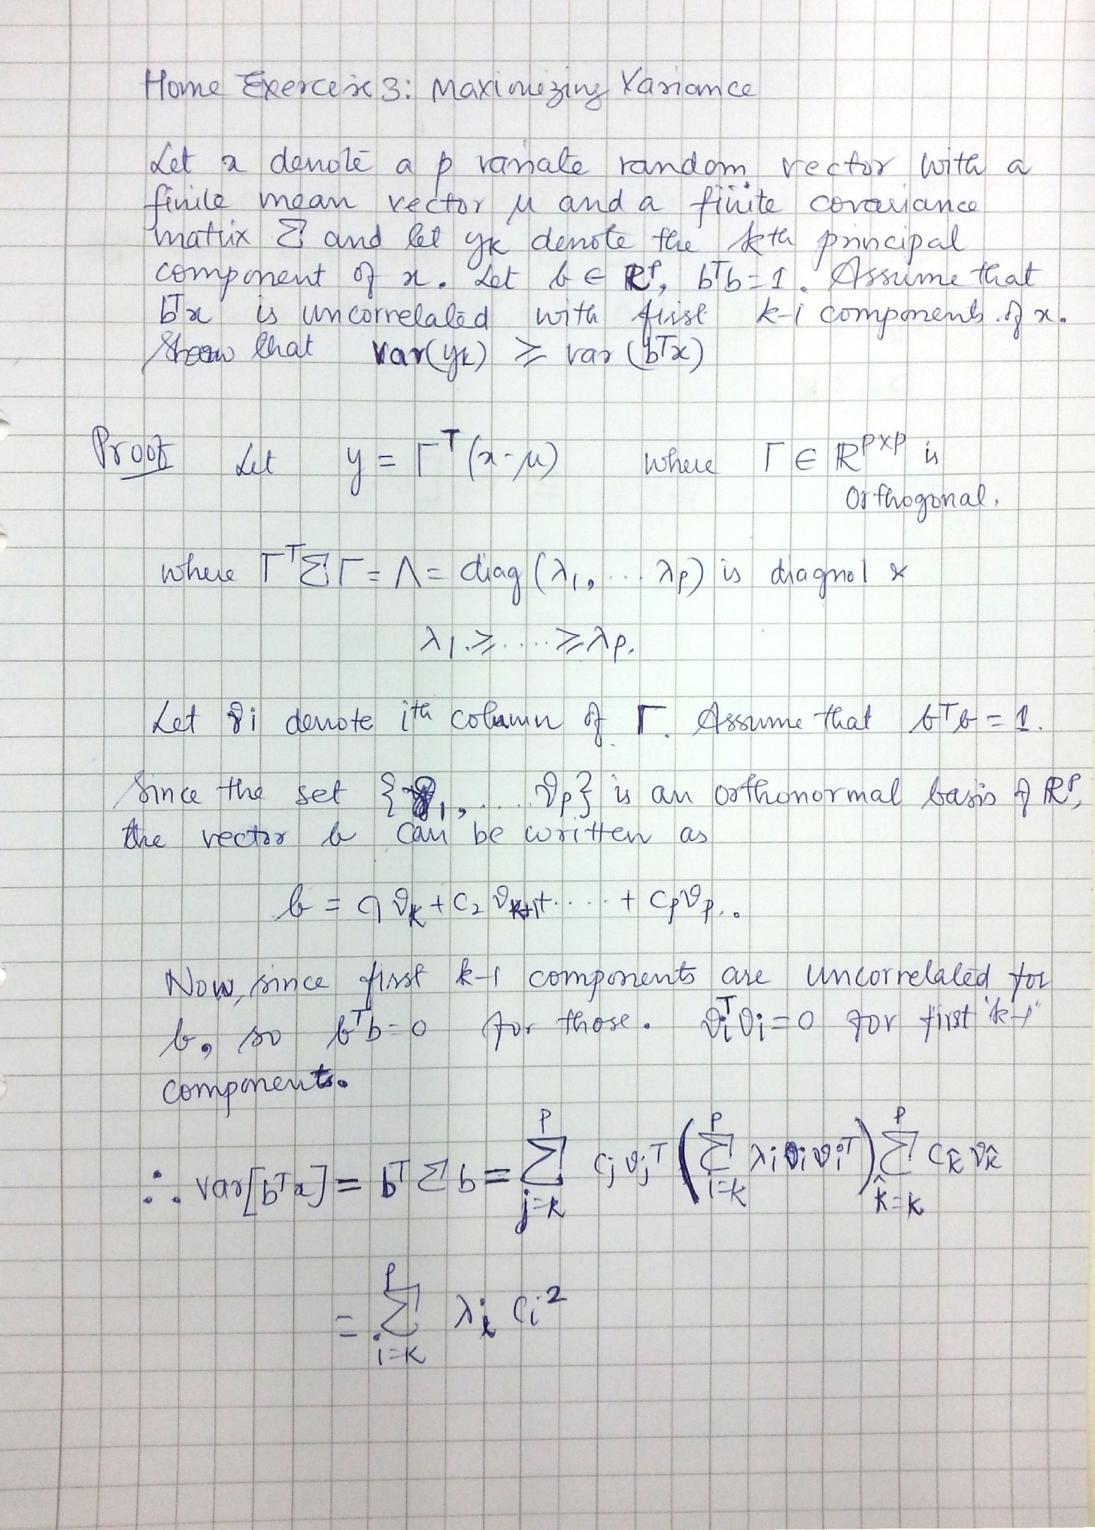Srikanth Gadicherla, 546195 January 29, 2016

